A Data Mining Approach to Discover Significant Determinants of Obesity.

Tahabi Hossain
Computer Science Engineering American International University-Bangladesh
Dhaka, Bangladesh
22-47610-2@student.aiub.edu

Victor Stany
Computer Science Engineering American International University-Bangladesh
Dhaka, Bangladesh
stany@aiub.edu
Amina Ferdous
Computer Science Engineering American International University-Bangladesh
Dhaka, Bangladesh
22-47822-2@student.aiub.edu

Md Tanvir Islam Akib
Computer Science Engineering American International University-Bangladesh
Dhaka, Bangladesh
22-47816-2@student.aiub.edu

Abstract— Obesity is a significant problem in the field of public-health, but most studies are focused on black-box prediction, rather than discovery of determinants. Our data-mining pipeline incorporated a transparent, end-to-end pipeline to stratify seven groups of obesity and determine the major drivers with the help of a public survey (N = 2,111). Categorical variables were binary/one-hot coded, continuous variables were standardized to z-scores, and the stratified train-validation-test split was 70/15/15. Logistic Regression, linear SVM, k-Nearest Neighbors, Decision Tree and Random Forest are five supervised learners that were trained under the same preprocessing. The accuracy, macro-precision / recall / F1, and macro ROC-AUC (one- vs-rest) were used to assess performance. Random Forest generalized best (Accuracy = 0.9527, Macro-F1 = 0.9514, Macro ROC-AUC = 0.9969), then Decision tree and Logistic regression, kNN and linear SVM did not perform as well at the boundaries between classes. Explainability gave more emphasis to the determinant discovery: Weight and Height were always global anchors, and the Age and FCVC (frequency of vegetable consumption) were found to be influential across strata. Weight dominance in all classes exhibited by per-class permutation importance (ΔF1, Random Forest); the dominance of Height was found in the most preponderant classes (Insufficient/Normal/Overweight-I); the dominance of FCVC was determined in the most severe cases; the dominance of Age was achieved at the threshold of the Overweight-II/Obesity-II; and the most informative TUE/NCP/CH2O was in the case of Overweight-II. The pipeline gives precise, interpretable results which can be used in screening and triage, as well as sets actionable levers in prevention (diet quality, activity, hydration, screen time, meal regularity).
Keywords—Obesity prediction; Determinant discovery; Random Forest; Permutation importance; Explainable machine learning; Multiclass classification; Data mining; Public health.

Introduction
Obesity is a big and exponentially increasing problem of the twenty-first century public health. Obesity or overweight means having excessive fat, which is damaging to health. Individuals with a body mass index (BMI) of 25 or more can be termed as being overweight whereas individuals with a BMI of 30 or more are termed as obese. By the year 2019, it was estimated that higher-than-normal BMI was associated with an estimated 5 million deaths caused by noncommunicable diseases (NCDs). Both the prevalence of overweight and obesity among the adult population and the children are on the increase worldwide. The percentage of adults receiving the body weight of 18 years and above who are obese increased more than twice between 1990 and 2022 to 16 percent. Moreover, the percentage of overweight children and adolescents aged 5-19 doubled all around the world, between 2 and 8. Obesity and overweight is a great increase in the risk of a variety of chronic diseases, such as heart disease and stroke. They are the major causes of mortality in the world. Worldwide, there has been a fourfold increase in the population of people with diabetes since 1980. Excess weight can also lead to such musculoskeletal disorders as osteoarthritis. Obesity causes multiple types of cancer such as endometrial, breast, ovarian, prostate, liver, gallbladder, kidney and colon cancers. [1].
Obesity is a complex combination of genetic, behavioral, and environmental factors that are not always well represented by the conventional regression models [2]. Although early prevention is essential, researchers have noted that it is difficult to establish key variables since the data of obesity is not always the same, and the traditional tools of analysis are limited [3]. The growing global obesity epidemic has created an urgent need to find novel forms of analytical methods that are beyond conventional statistical modeling. The data mining and machine learning techniques pose a great threat to these substitutes because they can handle large, diverse volumes of data, discover the latent relationships, and identify the key variables that contribute to the risk of obesity [2]. Over the last several years, a variety of non-homogeneous data types, including electronic health records (EHRs), lifestyle and demographic indicators, and data mining, machine learning (ML), and artificial intelligence (AI) methods, have been integrated to form more precise obesity prediction models [4]. These techniques are superior to regression processes because they can identify the hidden relationships and nonlinear patterns which are otherwise difficult to detect using conventional statistics [5]. Overall, the obesity research has transformed the descriptive epidemiology approach into predictive analytics because the data-based approaches have been developed rapidly. The integration of explainable artificial intelligence (AI), data visualization, and machine learning (ML) has high potential to find high-risk people and assist them in managing and preventing obesity with specific strategies [6]. The study emphasizes the identification and prioritization of essential cofactors that cause obesity. It provides a detailed and action-oriented view, unlike much of the current literature, which mainly looks at predicting obesity levels.

Literature Review
Three streams within "data mining for determinants of obesity" are the topic of this review: (i) the key determinants and risk variables that may be identified by prior studies; (ii) how to predict obesity across age groups and data types using data mining and machine-learning (ML) models; and (iii) how to transform prediction into interpretation by making use of explainability and feature-importance.
Multi-level drivers, such as behavioral (diet, physical inactivity), sociodemographic (age, sex, education, and income), psychosocial, and generally more obesogenic, were listed in a large systematic review (2010-2020). It also emphasized that it is important to associate these determinants to preventive and predictive machine learning (ML) methods. This positions ML as a tool of scaling risk factors, as well as the classifier. These determinants recur in populations without universal rankings, but their relative importance varies by cohort and context. This promotes research which quantifies effect sizes (or significance) on specific data sets [7]. Interpretable machine learning with adults showed gradient-boosted models ranked behavior and clinical factors highly and contributed to prediction through SHAP, showing how prediction could be related to practical predictors [8]. To identify risk factors to predict obesity based on age-specific heterogeneity and the significance of stratified modeling, age-specific machine learning analyses were proposed on the basis of KNHANES data [9]. In a big EHR-based study, gradient-boosted decision trees were trained to predict adolescent obesity using routine records, with good discrimination and practicality [10]. It is observed that with the appropriate design deep models can be accurate and interpretable as demonstrated by high accuracy of a particular deep model (DeepHealthNet) that utilized explainability (SHAP/feature analysis) to relate model outputs to risk factors in teenagers [11]. In a recent comparative study, Random Forest (with the highest variable importance age) was better than SVM/Logistic at the overall accuracy, which is multiclass obesity categorization. This indicates the performance dispersion, as well as the average supremacy of a small number of anthropometrics as predictors [12]. Explainability is increasingly being used in conjunction with machine learning to achieve more than black-box accuracy. Relevant cardiometabolic risk situations have had interpretable pipelines, based on SHAP and using significance indices as well as visual dashboards, to illustrate the way in which feature contributions can be communicated to policymakers and physicians. This trend, unlike model-only reporting, prefers a determinant-oriented obesity analytics lens. Although prior research seldom compares the importance of the class-specificity (i.e., which attributes are important to each level of obesity) and standardizes the importance between many different algorithms, explainable machine learning (ML) provides the connection between good classifiers and practical determinants [8].
Determinant discovery is often model based or data specific in the absence of a single data-mining pipeline that compares various techniques and gives similar feature importance results across those techniques. A methodical association of risk factors and ML methods is particularly required in the systematic literature review [7]. Class sensitive explanations are scarce. Not many studies estimate the per-class importance of multiclass obesity levels, which is essential to target prevention (i.e., features that are specific to cause "Overweight I" vs. "Obesity II). Most of the studies show global significance. This necessity is revealed in comparative studies that depict confusion among neighboring classes [10].
These gaps are directly addressed by A Data Mining Approach to Discover Significant Determinants of Obesity by reporting global and per-class determinant importance to determine the factors contributing to each type of obesity, and presenting interpretable outputs, as reported by the study, that are consistent with the explainability direction of recent literature.

Methodology

Study Objective and Workflow

Fig 1 shows the end to end workflow that was used in this research in prediction of obesity and determinants discovery. The first phase was Data Collection whereby, pertinent anthropometric, dietary and behavioral information was obtained. In the Data Preprocessing and Transformation phase, missing values and outliers were handled, categorical variables were one-hot encoded, and continuous attributes were standardized. The Data Splitting step divided the dataset into 70% training, 15% validation and 15% test sets by using stratified sampling to maintain balance of classes. Then, in Model Training and Tuning, five modeled algorithms were trained with regular preprocessing pipelines, which were Logistic Regression, SVM-linear, kNN, Decision Tree and Random Forest. The held-out test set was then model-evaluated and compared using accuracy, macro-precision, macro-recall, macro-F1 and macro ROC-AUC. Lastly, Explainability and Interpretation stage used Permutation Feature Importance (PFI) to determine global and per-class predictors of obesity. Such orderliness of pipeline guaranteed methodological transparency and reproducibility and pointed out the steps that had the most significant effect on predictive performance and interpretability.

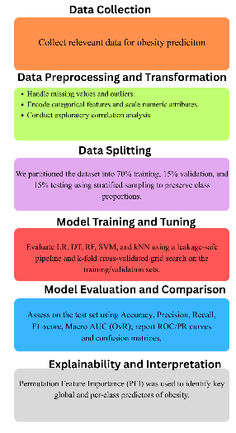

Fig:1

Dataset and Variables
The data set, used in this article, includes 2,111 records that describe personal anthropometric, dietary, and behavioral variables pertaining to the risk of obesity. The records are assigned to the unique individual, and the variables are categorical and numerical, where the target variable is the level of obesity. The data set was transformed to encode categorical variables by treating them as binary variables (0 = No, 1 = Yes) and normalised all continuous variables with the Z-Score normalisation, to allow comparison between data sets across different measurement scales.
i) Categorical Variables
Feature | Description | Encoding
Gender | Biological sex of the individual | 0 = Female, 1 = Male
family_history_with_overweight | Family history of overweight/obesity | 0 = No, 1 = Yes
FAVC | Frequent consumption of high-caloric food | 0 = No, 1 = Yes
SMOKE | Smoking habit | 0 = No, 1 = Yes
CAEC | Consumption of food between meals | 0 = No, 1 = Yes (for each level: sometimes, frequently, always)
SCC | Monitoring daily caloric intake | 0 = No, 1 = Yes
CALC | Alcohol consumption frequency | 0 = No, 1 = Yes (for each level: sometimes, frequently, always)
MTRANS | Primary mode of transportation | 0 = No, 1 = Yes (automobile, motorbike, bicycle, public transport, walking)

Multi-level variables like CAEC, CALC and MTRANS were one-hot encoded to result in several binary columns representing each sub-category.

ii) Numerical Variables
All numerical features were standardized using Z-Score Transformation:
z=(x−μ)σz = \frac{(x - \mu)}{\sigma}z=σ(x−μ)​
where μ\muμ and σ\sigmaσ represent the mean and standard deviation of each feature.

Feature | Description | Value Range / Unit
Age | Age of participant | Years (numeric)
Height | Height of participant | Meters (numeric)
Weight | Weight of participant | Kilograms (numeric)
FCVC | Frequency of vegetable consumption | 1 – 3
NCP | Number of main meals per day | 1 – 4
CH2O | Daily water consumption | 1 – 3
FAF | Weekly frequency of physical activity | 0 – 3
TUE | Daily technology usage time | 0 – 2

iii) Target Variable

Label | Description
0 | Insufficient Weight
1 | Normal Weight
2 | Obesity Type I
3 | Obesity Type II
4 | Obesity Type III
5 | Overweight Level I
6 | Overweight Level II

The target variable uses seven mutually exclusive categories of obesity, thus allowing the multi-class classification.

C. Data Preprocessing Summary

The two-category categorical variables were encoded as binary (0/1) and those with more than two categories were one-hot encoded and all continuous variables were standardized using z-score and Obesity target was label-encoded (0-6). To ensure that the class proportions remained unchanged, we used a stratified 70/15/15 train-validation-test split, where missing or inconsistent values were imputed on the conservative side. Preprocessing and modeling was done in Python through scikit-learn.

D.Exploratory Data Analysis

Spearman rank correlations were calculated to describe monotonic relationships and eliminate redundancy among predictors, the first step in a series of steps before actual supervised learning on lifestyle/clinical predictors.

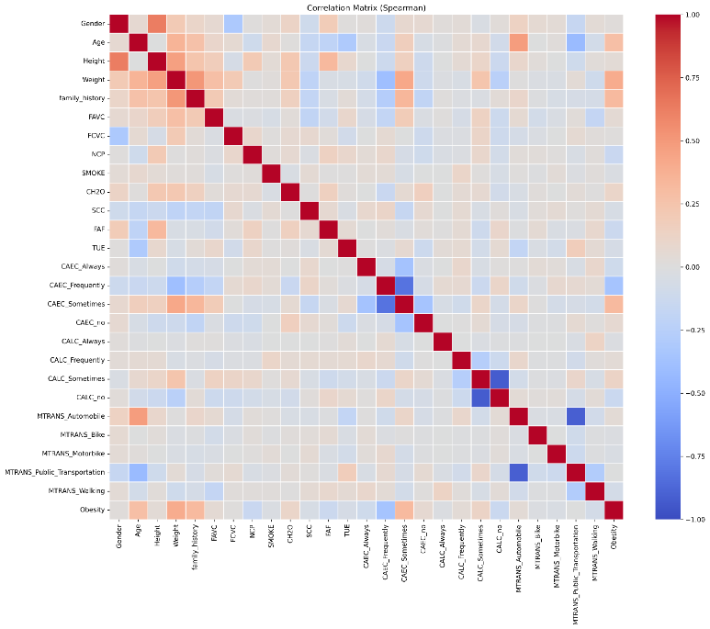
Fig:2
Fig. 2 demonstrates pairwise monotonic relationships between features and target variable in the form of the Spearman correlation matrix. There are high positive relationships between the variables of Weight and Height, which proves that they are the dominant ones in determining whether a person is obese. The relationships with behavioral variables (FCVC, FAF, CH2O, NCP, and TUE) are relatively weak but consistent. As can be seen in Fig. 2, marginal relationships are mainly affected by anthropometrics (Weight, Height), but diet/activity attributes (FCVC, FAF, CH2O, NCP, TUE) have a lesser but still reliable monotonic relationships-as expected of the performance difference between linear baselines and tree ensembles. The reasons behind these observations are that z-score normalization is necessary to stabilize gradient-based models (LR, SVM) and non-linear ensembles (DT, RF) are required to model higher-order dependencies.The training and validation and test data were stratified into Train (70%), Validation (15%), and Test (15%) splits to preserve the class balance, which ensures strong model assessment.

E.Class Distribution Across Data Splits

Class | Train_Count | Train_% | Val_Count | Val_% | Test_Count | Test_%
Insufficient_Weight | 190 | 12.87 | 41 | 13.00 | 41 | 13.00
Normal_Weight | 201 | 13.61 | 43 | 13.57 | 43 | 13.57
Obesity_Type_I | 245 | 16.59 | 53 | 16.72 | 53 | 16.72
Obesity_Type_II | 208 | 14.08 | 44 | 13.88 | 45 | 14.20
Obesity_Type_III | 227 | 15.37 | 49 | 15.46 | 48 | 15.14
Overweight_Level_I | 203 | 13.74 | 44 | 13.88 | 43 | 13.57
Overweight_Level_II | 203 | 13.74 | 43 | 13.57 | 44 | 13.88

In this table, the number and percentage of samples by category of obesity in each of the dataset partition (Train, Validation, and Test) are shown. The stratified sampling ensured almost equal proportions between splits.

F. Learning Algorithms and Pipeline
Five supervised classifiers were applied in scikit-learn pipelines to make sure that we did the same preprocessing (one-hot encoding of categorical variables; z-score standardization of continuous/ordinal variables). Stratified sampling was applied to divide the data into Train (70%), Validation (15%), and Test (15%) with class proportion being the same in each split.

G. Evaluation Metrics and Interpretability

Accuracy, Macro-Precision, Macro-Recall and Macro-F1 were reported by us to balance the contribution of classes to the seven obesity categories. This was measured through Macro ROC-AUC in a one-vs-rest (OVR) scheme. Confusion matrices and per-class ROC curves were used to visualize qualitative separability. To explain the model, we presented (i) global feature importance per model and (ii) per-class permutation importance on the validation set using DF1 as the scoring function to demonstrate the predictors that appear to have the most significant impact on each class boundary.

H. Algorithm and Modelling (Five Models)

Each learner works within a seven-class OVR system. LR and RF output probabilities; SVM-linear gives decision values; DT and KNN give class votes/posteriors. The following is a summary of the learning principles and the configurations.

i) Logistic Regression (LR)
Model. LR models the log-odds linearly and maps them through the logistic link. Multi-class prediction uses one-vs-rest (OVR) with class probabilities and argmax decision. The logistic function is:
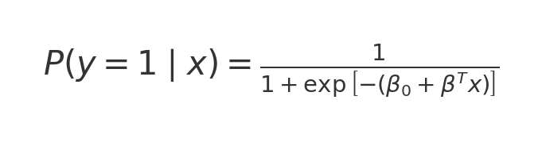

ii) Linear Support Vector Machine (SVM-linear)
Model. A linear SVM maximizes the margin subject to hinge-loss slack. Multi-class is implemented via OVR with decision functions and argmax selection. The primal optimization is
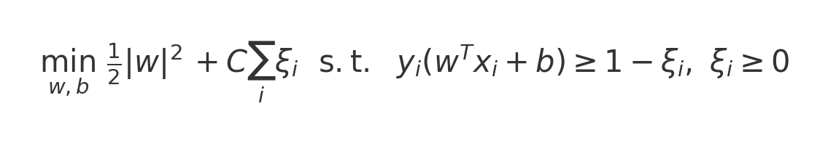

iii) k-Nearest Neighbors (KNN)
Model. KNN predicts from neighborhood majority under a distance metric. With k = 11 and Minkowski distance (Euclidean for p = 2), the decision rule is:
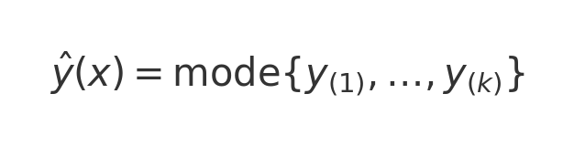

iv) Decision Tree (DT)
Model. A decision tree recursively partitions the feature space to reduce impurity; we use the Gini criterion:
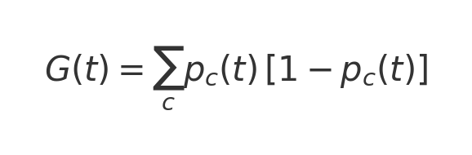

v) Random Forest (RF)
Model. RF ensembles M trees trained on bootstrap samples with random feature subsampling per split. The probability aggregation and final decision are:
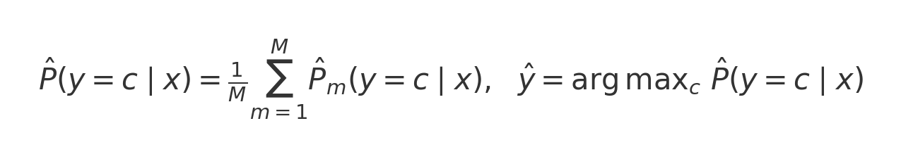

IV.Results

A.Overall Model Performance

Consolidated test metrics appear in Table I; validation metrics in Table II.

Table I


Table II



Table III
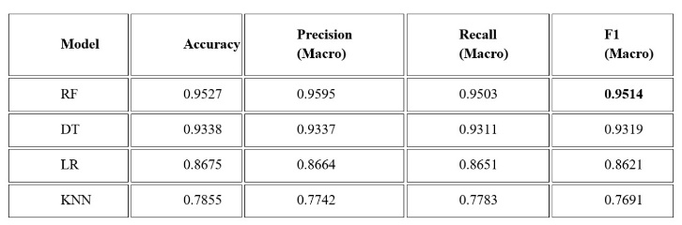
B.Visual comparisons:
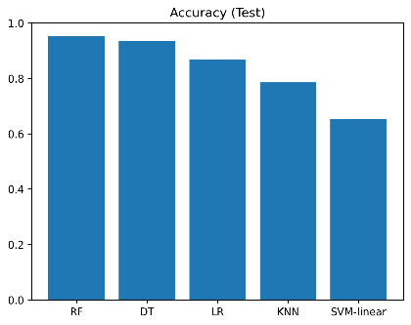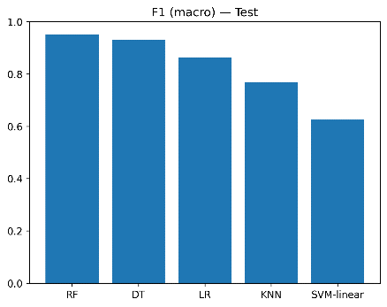
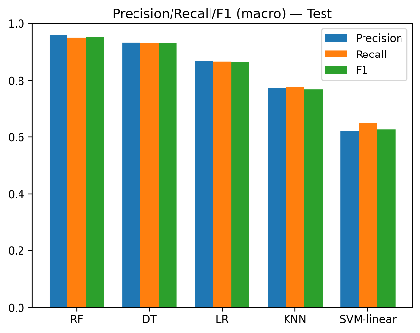

Fig:3
Key outcomes:
RF attained the best performance ( Accuracy 0.9527, F1-macro 0.9514), DT came next ( Accuracy 0.9338), and LR provided a good linear baseline ( Accuracy 0.8675). KNN (F1-macro ≈ 0.77) was sensitive to neighborhood-boundary but SVM-linear performed worse (F1-macro ≈ 0.62) as it only has the capacity to model non-linear class transitions. This order (RF > DT > LR > KNN > SVM-linear) reflects prior results in related obesity ML research where ensembles have been found to achieve higher results than single learners and the results are consistent with deep-learning systems that have shown high but less interpretable gains.Macro-averaged performance (Accuracy, Precision, Recall, F1) for each model across stratified splits. Random Forest (RF) and Decision Tree (DT) achieve perfect training F1 (=1.00) yet retain strong generalization on Validation and Test, while LR is mid-tier and KNN/SVM-linear underperform. Disjoint splits are computed using the same preprocessing and pipelines to compute values.
Split | Model | Accuracy | Precision_macro | Recall_macro | F1_macro
Train | DT | 1 | 1 | 1 | 1
Train | RF | 1 | 1 | 1 | 1
Train | LR | 0.8822 | 0.8816 | 0.8798 | 0.8785
Train | KNN | 0.826 | 0.8201 | 0.8211 | 0.8134
Train | SVM-linear | 0.6696 | 0.6422 | 0.6672 | 0.6436
Val | RF | 0.9558 | 0.9593 | 0.9546 | 0.9548
Val | DT | 0.9306 | 0.933 | 0.9279 | 0.9296
Val | LR | 0.8738 | 0.87 | 0.8691 | 0.8669
Val | KNN | 0.7666 | 0.7599 | 0.7637 | 0.7567
Val | SVM-linear | 0.6688 | 0.6282 | 0.6648 | 0.6329
Test | RF | 0.9527 | 0.9595 | 0.9503 | 0.9514
Test | DT | 0.9338 | 0.9337 | 0.9311 | 0.9319
Test | LR | 0.8675 | 0.8664 | 0.8651 | 0.8621
Test | KNN | 0.7855 | 0.7742 | 0.7783 | 0.7691
Test | SVM-linear | 0.653 | 0.62 | 0.6512 | 0.6249

Class-Specific Error Patterns (Confusion Matrices)
The confusion matrices reveal that RF and DT are almost diagonal with the residual confusion mostly occurring between similar severity scales (e.g.Normal Weight vs. Overweight I, Overweight I vs. Overweight II). KNN and SVM-linear demonstrate wider dispersion, which is why the macro-F1 and recall are lower.
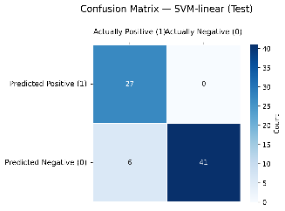
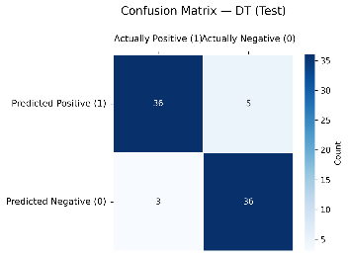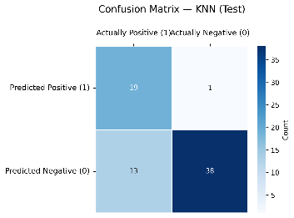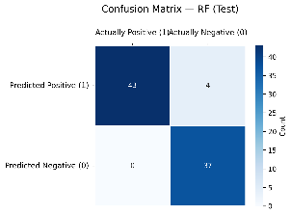
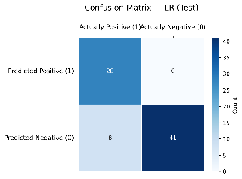

Test set confusion matrices; tree-based models have a more dominant diagonal and reduce cross-class errors.

Per-Class Separability (ROC, Test)
OVR ROC curves by class indicate that RF and DT significantly separate in all seven classes, and the AUCs of SVM-linear are lower when crossing mid-range boundaries of overweight/obesity.
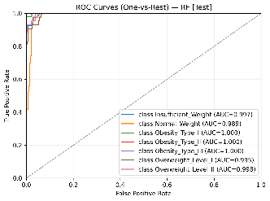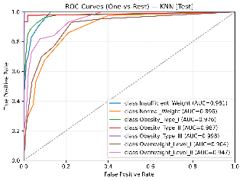
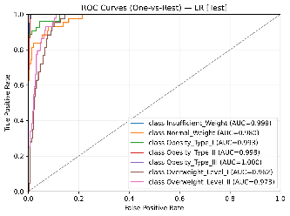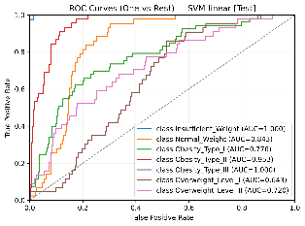
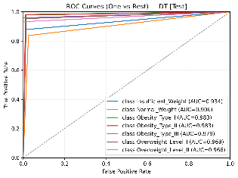
ROC curves at one-vs-rest of the test set with discrimination at the class level each model.

Global Feature Importance (All Models):
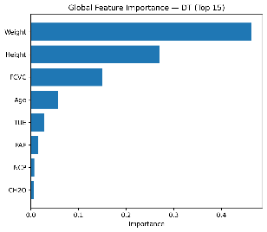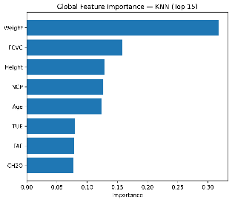

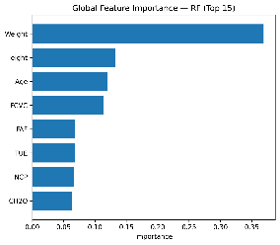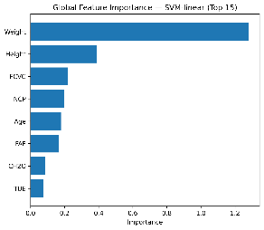

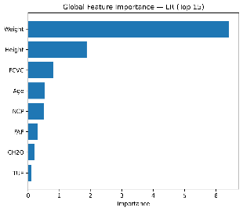

Global importance rankings per model; Weight and Height dominate, with diet/activity variables showing consistent secondary influence

Per-Class Permutation Importance:

We report per-class permutation importance only for the best-performing model (Random Forest) to present a concise yet representative view of class-specific drivers. Weight and Height are universal drivers in all classes, and FCVC and Age differ in their effects in strata of Overweight and Obesity on the validation set. These transitions between the level of Normal/Overweight and Obesity have even more color with the help of behavioral factors FAF (physical activity), CH2O (water intake) and TUE (screen time). These trends are consistent with class-related risk patterns on a pediatric/adolescent and an adult cohort with parental/behavioral factors moderating risks over Height Weight.
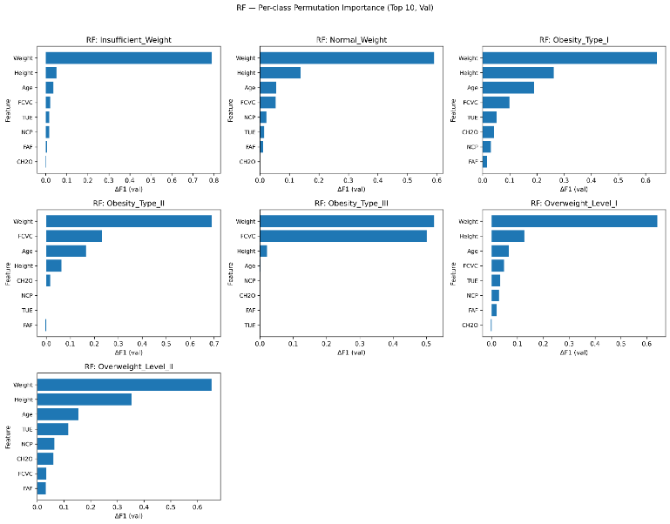

Takeaway: In the methods (supported by world significance and RF per-class findings), the hierarchy of determinants is stable:
Weight → Height → Age/FCVC → (FAF, TUE, CH2O, NCP).
RF provides the strongest predictive reliability; LR/DT offer transparent interpretability; KNN/SVM-linear are more sensitive to boundary overlap and linearity.

G. Feature Importance (Key Determinants):
Causal determinants (universal): Weight, Height.
Significant and consistent: Age, FCVC (frequency of vegetable consumption).
Behavioral modulators: FAF (physical activity), TUE (screen time), CH2O (water intake), NCP (main meals).
Takeaway hierarchy:
Weight - Height - Age/FCVC - (FAF, TUE, CH2O, NCP)
Per-class trends (RF, validation):
Not enough/Normal: FCVC and CH2O are used to draw the healthier profiles apart; TUE is used to regulate the borderline cases.
Overweight I/II: FCVC shift is also important, but the age and FAF make the active and inactive subgroups.Obesity I/II/III: FCVC/FAF increase severity transition; Weight and Height dominate.

V. Discussion
The current research compared five actively supervised learners against a dataset of multiclass obesity and highlighted the importance of interpretable discovery of determinants. Random Forest showed the highest generalization using macro measures and ROC-AUC, then Decision Tree and Logistic Regression, KNN and linear SVM performed poorly, especially at the overlapping boundaries. The confusion matrices revealed that the majority of the mistakes were made between the neighboring categories (e.g., Normal vs. Overweight I/II), which demonstrated the nonlinear relationships between the anthropometric and behavioral variables. In addition to accuracy, the analysis was more explainable. Global significance and per-class permutation (DF1, RF) settled on a stable determinant hierarchy founded on Weight and Height, with other, class-specific signal provided by FCVC, FAF, CH2O, NCP, and TUE. Height generally came in second in terms of Insufficient/Normal/Overweight I, but FCVC increased dramatically in higher severities (strong in Obesity II; co-dominant with Weight in Obesity III). The age was statistically significant with a peak at Overweight II/Obesity II; TUE/NCP/CH2O was the most informative during the Overweight II with a small marginal effect on FAF. Global (or per-class) agreement enhances the reliability of such patterns as indicative of clinical meaningful levers and not artifacts of the dataset. The pipeline is feasible in terms of screening and triage: It can take standard format inputs, is light to compute and results in explanations that can be used to inform focused counseling.

VI. Conclusion
This study provides correct prediction and interpretable determinant identification of multiclass stratification of obesity. Random Forest (Accuracy = 0.9527, Macro-F1 = 0.9514, Macro ROC-AUC = 0.9969) was the best at generalization, with Decision Tree and then Logistic Regression ranking lower on the shared boundaries, and KNN/SVM-linear the weakest. In addition to accuracy, the analysis provided a consistent hierarchy of determinants: The universal anchors include Weight and Height, whereas FCVC, FAF, CH2O, NCP, and TUE contribute significant signal. The boundaries were further clarified by per-class permutation (RF), with the dominance by weight in all seven classes; height is usually second in Insufficient/Normal/Overweight I; FCVC is dominant in overweight type III with a minor effect in type II, and age contributing steadily with a maximum in overweight type II; and minimal effect with a small marginal effect overall of the FAF. These findings yield actionable levers—improving diet quality (↑FCVC), activity where impactful, managing screen time (↓TUE), and supporting hydration (↑CH2O) and meal regularity (NCP)—and provide an interpretable, deployment-ready foundation for external validation, calibration/fairness audits, and stronger calibrated ensembles with model-agnostic explanations.

VII. Limitations and Future Work
We have limited ourselves to a single, cross-sectional survey dataset without biomarkers; to self-reported, discretized variables; to no external validation, calibration, fairness audits, and no decision-analytic assessment; to classic learners only; and to explainability with RF based on permutation importance. Future work will improve variables by adding physiological markers, perform external/temporal validation, introduce calibration and subgroup fairness audits, will consider ordinal classification and stronger calibrated ensembles (boosting/stacking), standardize explainability with SHAP and PD/ICE and threshold selection relevant to screening or referral use-cases, harden the pipeline to deployment with robustness tests, drift monitoring and threshold selection matching screening or referral use-cases.
VIII.References

[1] World Health Organization, "Obesity," World Health Organization, [Online]. Available: https://www.who.int/health-topics/obesity. [Accessed: October 8, 2025].
[2] Z. Helforoush and H. Sayyad, “Prediction and classification of obesity risk based on a hybrid metaheuristic machine learning approach,” Frontiers in Big Data, vol. 7, article 1469981, pp. 1–17, Sept. 2024, doi: 10.3389/fdata.2024.1469981
[3] A. Khan, S. Borse, V. Bhoi, V. Patil, and U. Patel, “Obesity detection using machine learning techniques,” International Journal of Innovative Research in Technology (IJIRT), vol. 10, no. 11, pp. 20–23, Apr. 2024, ISSN: 2349-6002.
[4] M. Gupta, T.-L. T. Phan, H. T. Bunnell, and R. Beheshti, “Obesity prediction with EHR data: A deep learning approach with interpretable elements,” ACM Transactions on Computing for Healthcare, vol. 3, no. 3, pp. 1–25, July 2022, doi: 10.1145/3506719
[5] A. Alqahtani, F. Albuainin, R. Alrayes, N. Almuhanna, E. Alyahyan, and E. Aldahasi, “Obesity level prediction based on data mining techniques,” International Journal of Computer Science and Network Security (IJCSNS), vol. 21, no. 3, pp. 103–111, Mar. 2021, doi: 10.22937/IJCSNS.2021.21.3.14
[6] Y. I. Sulistya and M. Istighosah, “Obesity prediction with machine learning models: Comparing various algorithm performances,” International Journal of Artificial Intelligence in Medical Issues, vol. 3, no. 1, pp. 1–13, May 2025, doi: 10.56705/ijaimi.v3i1.181
[7] M. Safaei, E. A. Sundararajan, M. Driss, W. Boulila, and A. Shapi’i, “A systematic literature review on obesity: Understanding the causes & consequences of obesity and reviewing various machine learning approaches used to predict obesity,” Computers in Biology and Medicine, vol. 136, p. 104754, Aug. 2021, doi: 10.1016/j.compbiomed.2021.104754
[8] J. Du, S. Yang, Y. Zeng, et al., “Visualization obesity risk prediction system based on machine learning,” Scientific Reports, vol. 14, no. 22424, 2024, doi: 10.1038/s41598-024-73826-6
[9] Jeon Y., Ko S., Lim H. “Age-Specific Risk Factors for the Prediction of Obesity Using Machine-Learning Methods,” Frontiers in Public Health, vol. 11, pp. 1–12, 2023. doi: 10.3389/fpubh.2022.998782
[10] H. Rossman, S. Shilo, S. Barbash-Hazan, N. S. Artzi, E. Hadar, R. D. Balicer, B. Feldman, A. Wiznitzer, and E. Segal, “Childhood obesity prediction from nationwide health records,” medRxiv, preprint, Nov. 2020, doi: 10.1101/2020.11.09.20228247
[11] J. -H. Jeong, I. -G. Lee, S. -K. Kim, T. -E. Kam, S. -W. Lee and E. Lee, "DeepHealthNet: Adolescent Obesity Prediction System Based on a Deep Learning Framework," in IEEE Journal of Biomedical and Health Informatics, vol. 28, no. 4, pp. 2282-2293, April 2024, doi: 10.1109/JBHI.2024.3356580.
[12] M. H. Islam and M. Rana, “Prediction of Obesity among Adults and Adolescents Using a Machine Learning Approach”, ijmcr, vol. 13, no. 5, pp. 5144-5150, May 2025.

